**VEHICLE MANAGEMENT SYSTEM**

**USING SALESFORCE**

**SMART INTERNZ**

**NAAN MUDHALVAN**

### PROJECT REPORT

***Submitted By***

**SANJAY S (611220104128)**

**SRI NATH R (611220104150)**

**SUNILKUMAR A (611220104156)**

**THAMARAI KANNAN M (611220104163)**

***in partial fulfillment for the award of the degree***

***of***

**BACHELOR OF ENGINEERING**

***in***

**COMPUTER SCIENCE AND ENGINEERING**

**KNOWLEDGE INSTITUTE OF TECHNOLOGY,**

**SALEM-637504**

**VEHICLE MANAGEMENT SYSTEM**

**USING SALESFORCE**

**SMART INTERNZ**

**NAAN MUDHALVAN**

### PROJECT REPORT

***Submitted By***

**SANJAY S (611220104128)**

**SRI NATH R (611220104150)**

**SUNILKUMAR A (611220104156)**

**THAMARAI KANNAN M (611220104163)**

***in partial fulfillment for the award of the degree***

***of***

**BACHELOR OF ENGINEERING**

***in***

**COMPUTER SCIENCE AND ENGINEERING**

**KNOWLEDGE INSTITUTE OF TECHNOLOGY,**

**SALEM-637504**

**BONAFIDE CERTIFICATE**

Certified that this project report titled **“VEHICLE MANAGEMENT SYSTEM USING SALESFORCE”** is the bonafide work of **“SANJAY S (611220104128), SRINATH R (611220104150), SUNILKUMAR A (611220104156), THAMARAIKANNAN M (611220104163)”** who carried out the project work under my supervision.

|  |  |
| --- | --- |
| **SIGNATURE** | **SIGNATURE** |
| Dr. V. KUMAR M.E., Ph.D., | Mrs. R. SIVA GURU M.E., |
| **HEAD OF THE DEPARTMENT** | **FACULTY MENTOR** |
| **PROFESSOR** | **ASSISTANT PROFESSOR** |
| Department of Computer Science | Department of Computer Science |
| and Engineering, | and Engineering, |
| Knowledge Institute of Technology, | Knowledge Institute of Technology, |
| Kakapalayam, | Kakapalayam, |
| Salem- 637 504. | Salem- 637 504. |

-------------------------------------------- ---------------------------------------------------

**SPOC HEAD OF THE DEPARTMENT**

**ACKNOWLEDGEMENT**

At the outset, we express our heartfelt gratitude to **GOD,** who has been our strength to bring this project to light.

At this pleasing moment of having successfully completed our project, we wish to convey our sincere thanks and gratitude to our beloved president **Mr. C. Balakrishnan,** who has provided all the facilities to us.

We would like to convey our sincere thanks to our beloved Principal **Dr. PSS. Srinivasan,** for forwarding us to do our project and offering adequate duration in completing our project.

We express our sincere thanks to our Head of the Department **Dr. V. Kumar,** Department of Computer Science and Engineering for fostering the excellent academic climate in the Department.

We express our pronounced sense of thanks with deepest respect and gratitude to SPOC **Mr. T. Karthikeyan,** Assistant Professor Computer Science and Engineering Department, for his valuable and precious guidance and for having amicable relation.

With deep sense of gratitude, we extend our earnest and sincere thanks to Faculty Mentor **Mrs. R. Siva guru,** Assistant Professor, Department of Computer Science and Engineering for her guidance and encouragement during this project.

We would also like express our thanks to all the faculty members of our department, friends and students who helped us directly and indirectly in all aspects of the project work to get completed1 successfully.

**TABLE OF CONTENTS**

|  |  |  |
| --- | --- | --- |
| **TASK**  **NO.** | **TASK TITLE** | **PAGE**  **NO.** |
| 1 | **PROJECT SPECIFICATION** | 6 |
| 2 | **PREPARATION DATA MODELING** | 11 |
| 3 | **USERS AND DATA SECURITY** | 17 |
| 4 | **AUTOMATION** | 20 |
| 5 | **REPORTS AND DASHBOARDS** | 21 |
| 6 | **PROJECT REPORT/DEMONSTARTION** | 24 |

1. **PROJECT SPECIFICATION**

**1.1 Problem Statement:**

The challenge is to design and implement an effective and streamlined vehicle management system within Salesforce that caters to the needs of managing vehicles, travellers, and drivers in a way that enhances the overall operational efficiency and user experience. This system should facilitate efficient management of vehicles, the assignment of drivers, and the coordination of traveller’s, all while ensuring data accuracy and compliance.

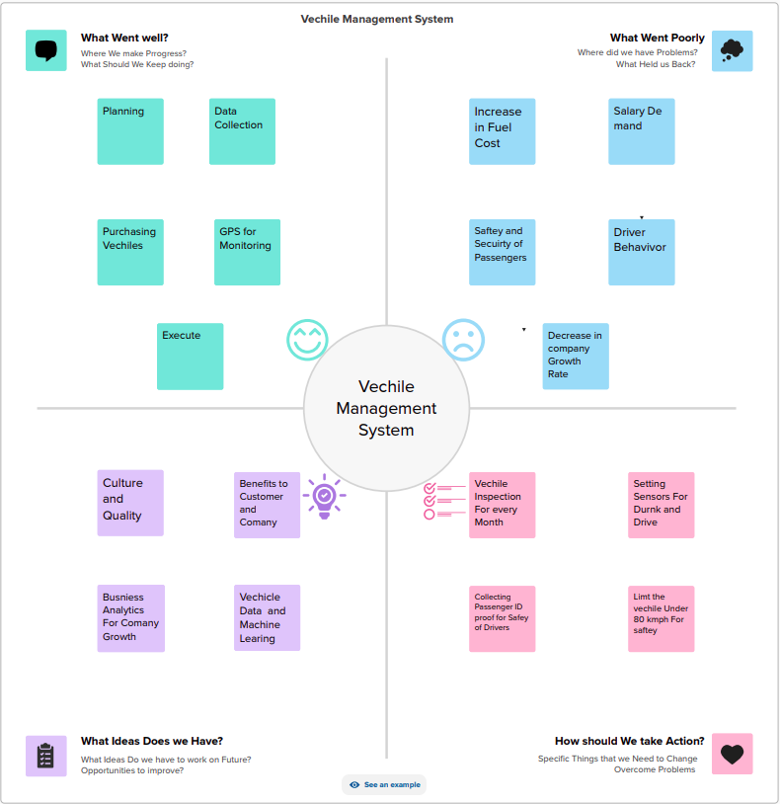

**1.2 Key Objectives:**

1. Vehicle Management:

* Efficiently track and manage an inventory of vehicles within Salesforce.
* Keep up-to-date records of vehicle details, including make, model, year, VIN, and maintenance history.
* Monitor vehicle availability, maintenance schedules, and usage history.
* Ensure accurate and accessible vehicle data for all authorized users.

1. Traveler Coordination:

* Facilitate the coordination of travelers and their transportation needs. Maintain traveller’s profiles with essential information, such as contact details, travel preferences, and special requirements.
* Enable the booking and assignment of vehicles to travelers based on their preferences and availability.
* Ensure seamless communication and notifications to travelers regarding their transportation arrangements.

1. Driver Assignment:

* Efficiently assign drivers to vehicles and trips.
* Keep records of driver details, licenses, certifications, and availability.
* Match drivers with appropriate vehicles and ensure compliance with legal and safety requirements.
* Enable easy scheduling and notifications for drivers and travelers.

**1.3 Design Thinking:**

1. **Empathize:**

* Understand the pain points and needs of users, including vehicle managers, travel coordinators, drivers, and travellers.
* Conduct interviews, surveys, and observe the current vehicle management processes.
* Identify challenges such as data inaccuracies, communication gaps, and inefficient vehicle allocations.

1. **Define:**

* Clearly define the problem and scope for managing vehicles, travelers, and drivers within Salesforce.
* Identify the objectives, including improving vehicle utilization, enhancing traveler experiences, and ensuring driver compliance.
* Create user personas for each stakeholder group and develop journey maps to visualize their interactions and pain points.

1. **Ideate:**

* Brainstorm potential solutions and features with a cross-functional team, considering Salesforce's capabilities.
* Explore innovative ways to automate and streamline vehicle assignments, driver tracking, and traveler communication.
* Consider integrating technologies like GPS tracking and mobile apps for real-time monitoring.

1. **Prototype:**

* Create a prototype or wireframe of the Salesforce-based vehicle management system.
* Build an MVP with essential features to demonstrate the concept.
* Gather feedback from users and stakeholders to refine the prototype.

1. **Test:**

* Test the MVP with a small group of users to evaluate usability and effectiveness.
* Collect feedback on system performance, user-friendliness, and alignment with their needs.
* Make necessary improvements and adjustments based on the feedback received.

1. **Implement:**

* Develop the full-scale vehicle management system within Salesforce, focusing on scalability and data security.
* Train users and administrators on system usage.
* Ensure seamless integration with existing Salesforce tools and databases.

1. **Measure:**

* Monitor KPIs to assess the system's impact, such as improved vehicle allocation, reduced communication delays, and increased traveler satisfaction.
* Continuously gather feedback from users and iterate on the system to address any issues or enhancements.
* Use analytics to track usage and adoption of the system.

1. **Iterate:**

* Continuously improve and adapt the system based on user feedback, data analysis, and evolving business needs.
* Ensure the system remains user-centric and aligned with the organization's objectives.

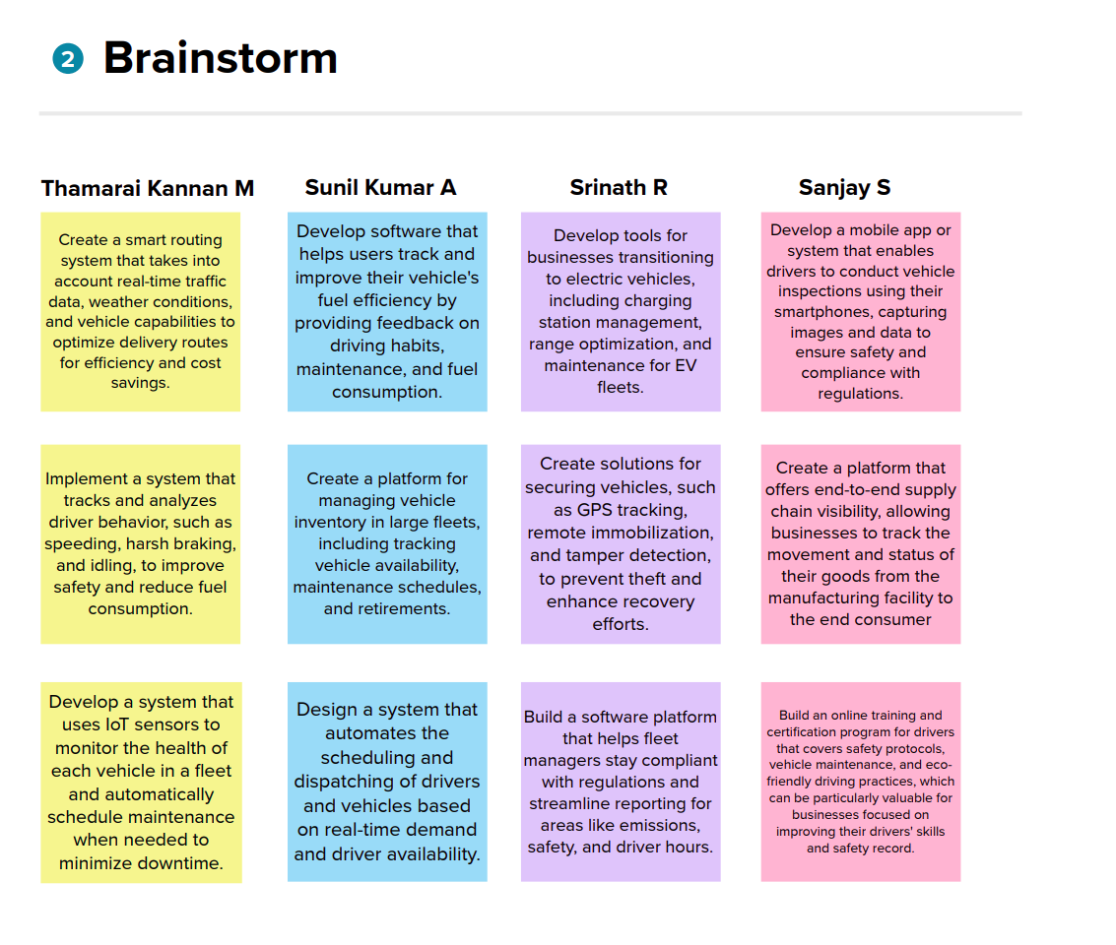

1. **PREPARATION DATA MODELING**
2. **Identify Objects:**

* Vehicle:

Create a custom object for vehicles. This should include fields such as make, model, year, VIN, current location, maintenance history, availability status, and any other relevant details.

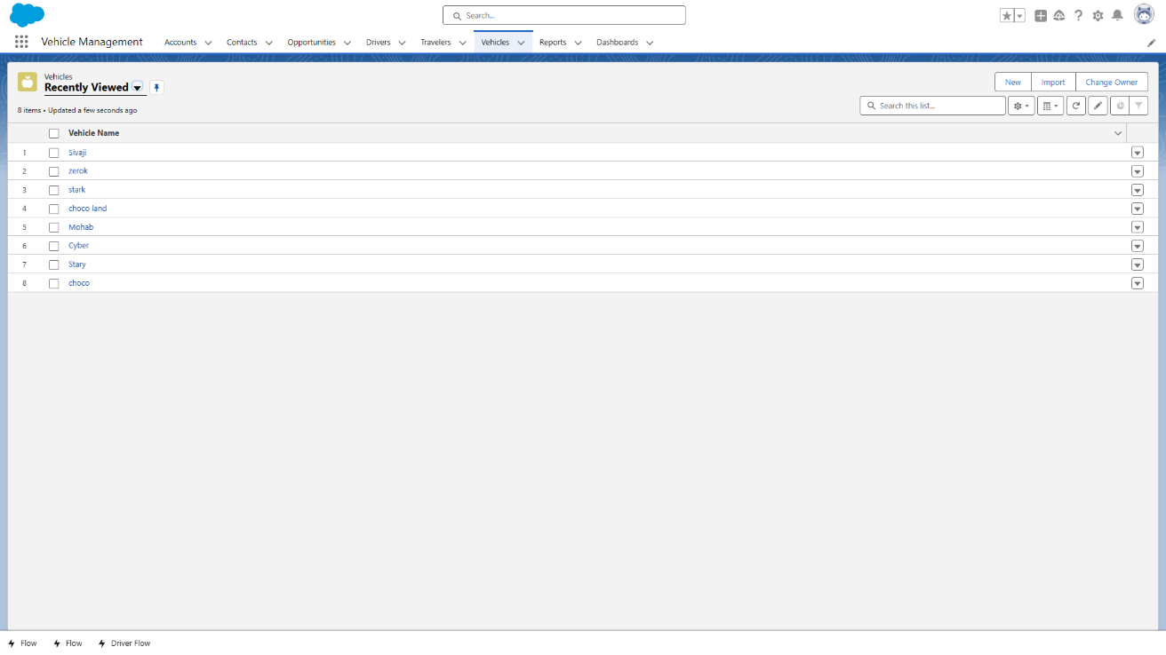

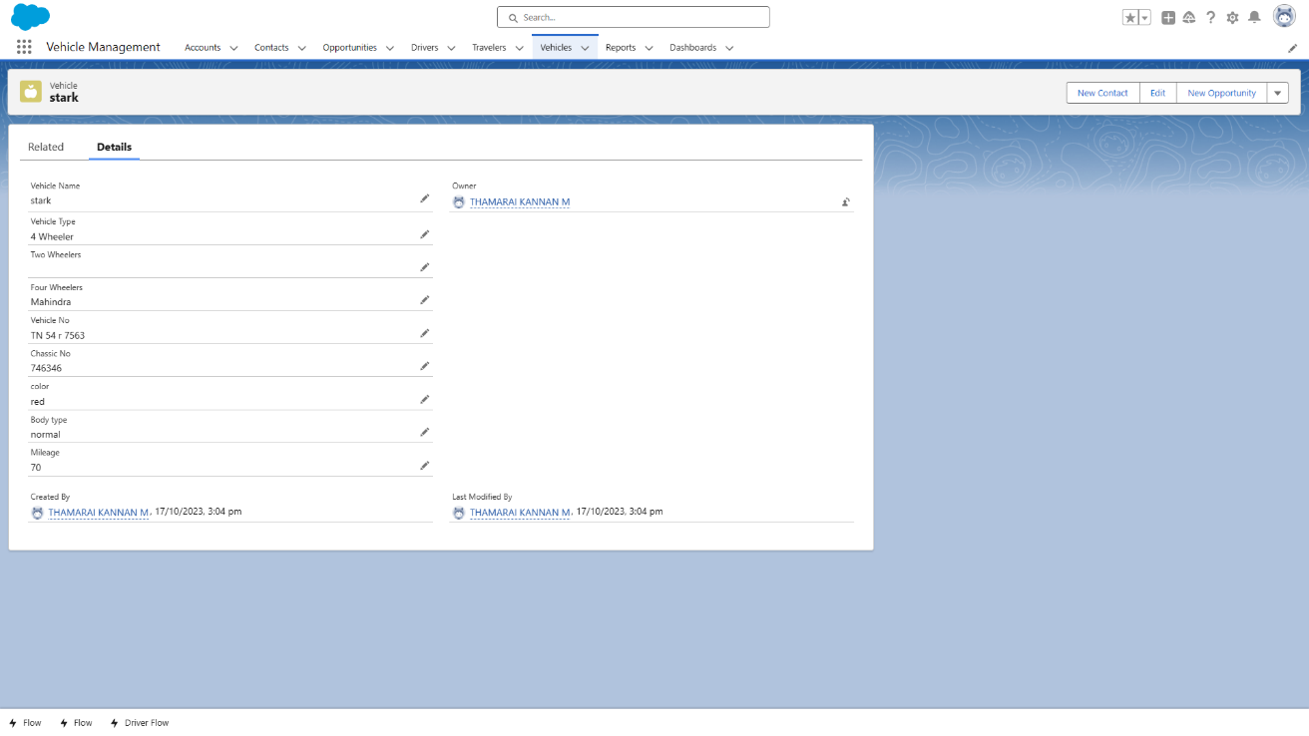

* Traveler:

Create a custom object for travelers. Fields may include traveler name, contact information, preferences, and any special requirements.

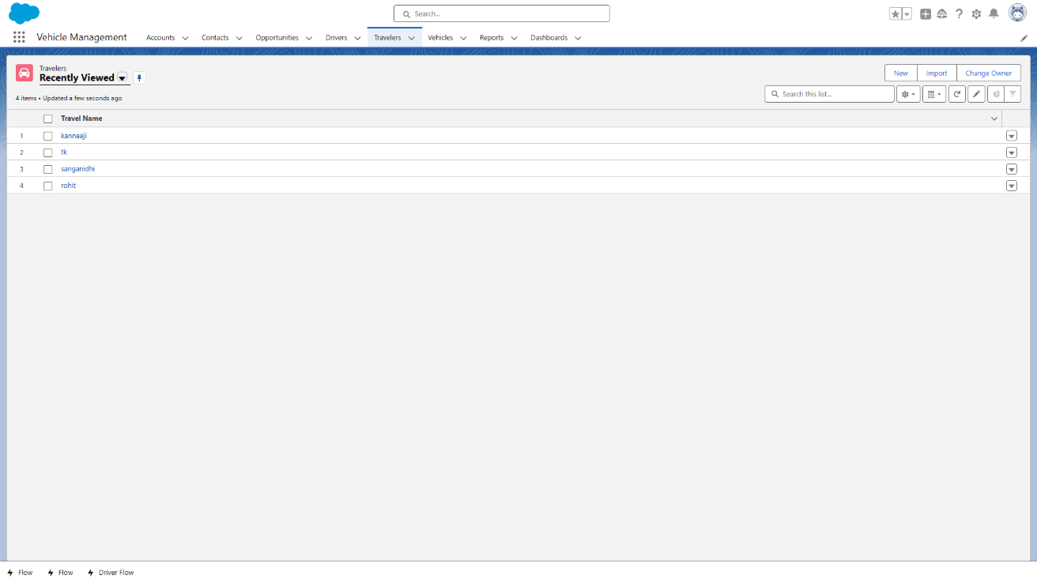

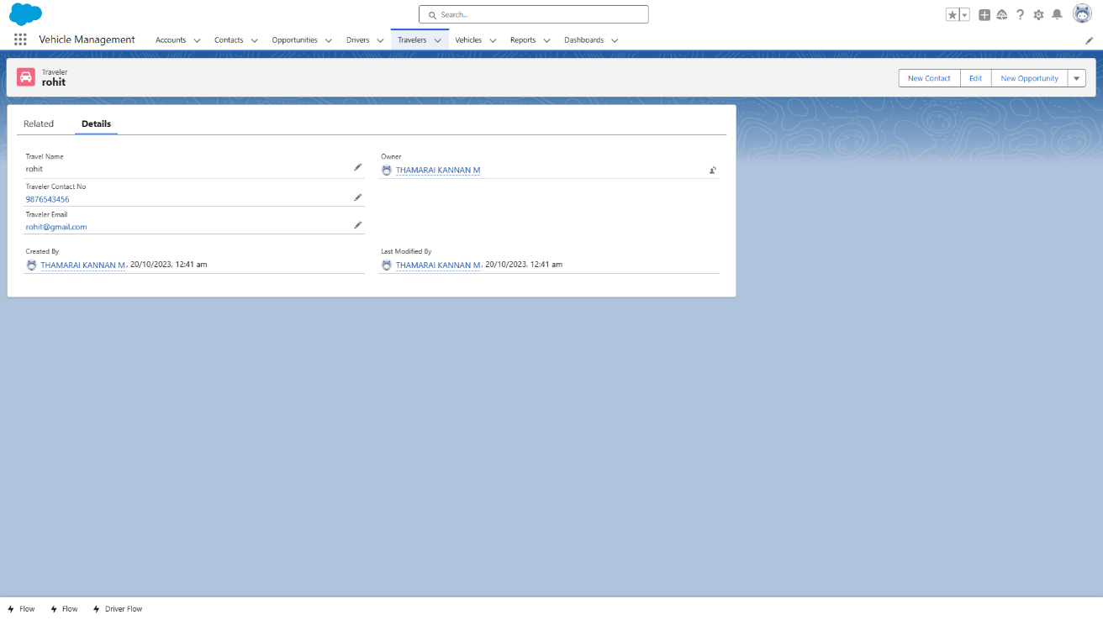

* Driver:

Create a custom object for drivers. Fields can include driver name, contact information, driver's license details, certifications, and availability.

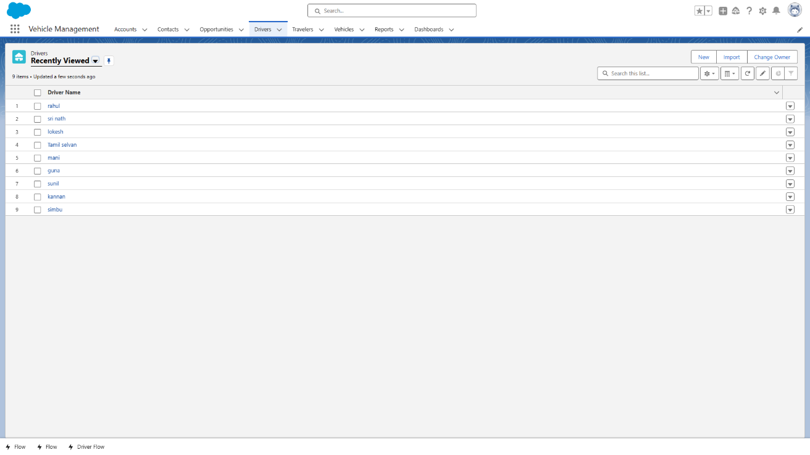

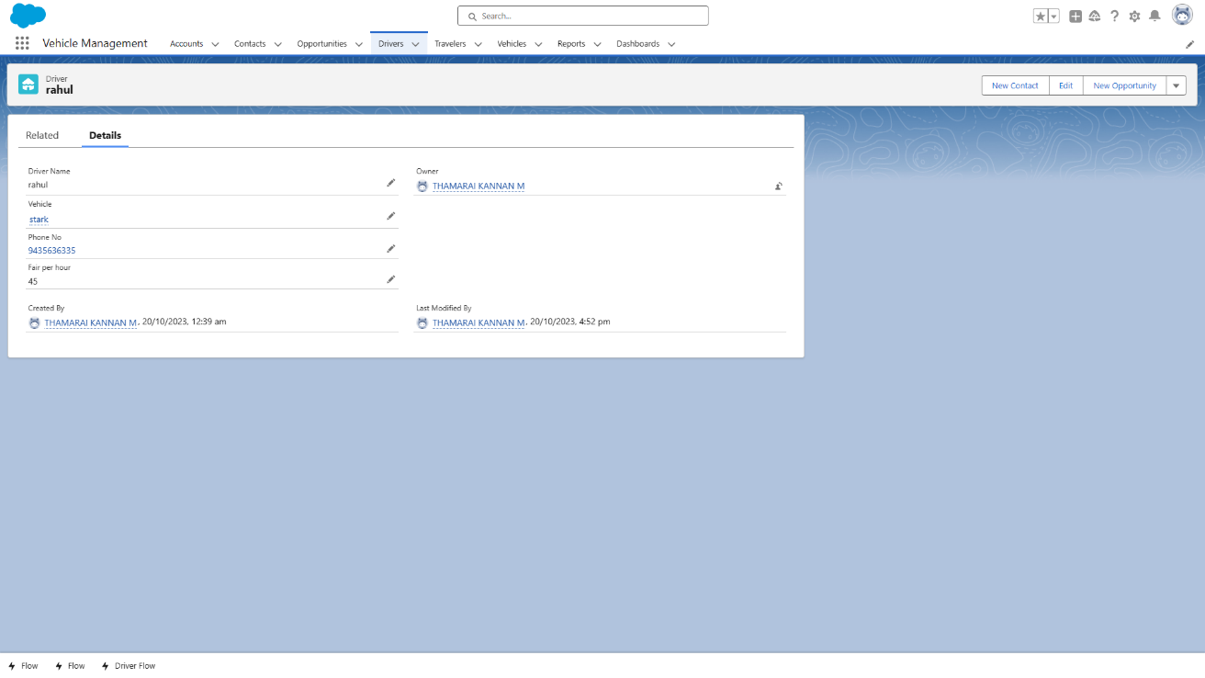

1. **Establish Relationships:**

* Vehicle-Traveler Relationship:

Create a lookup relationship from the Traveler object to the Vehicle object. This allows you to associate a specific vehicle with a traveler for a particular trip.

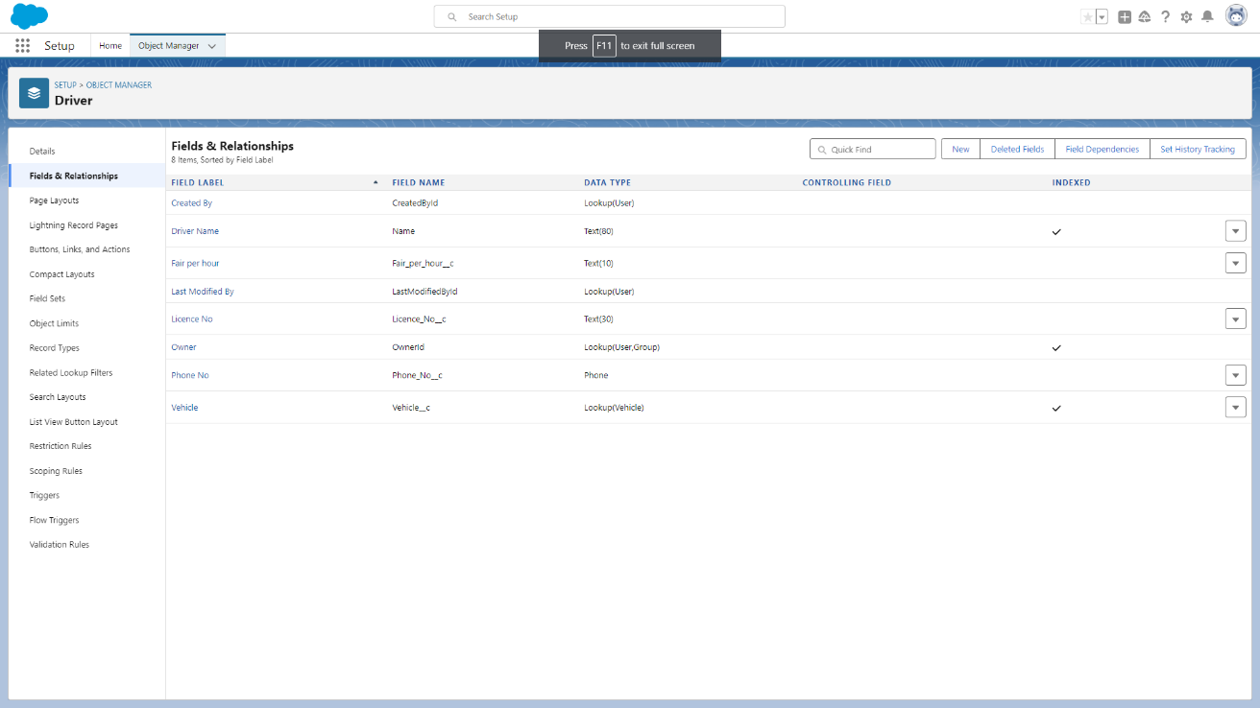

* Vehicle-Driver Relationship:

Create a lookup relationship from the Driver object to the Vehicle object. This links a driver to the vehicle they are assigned to.

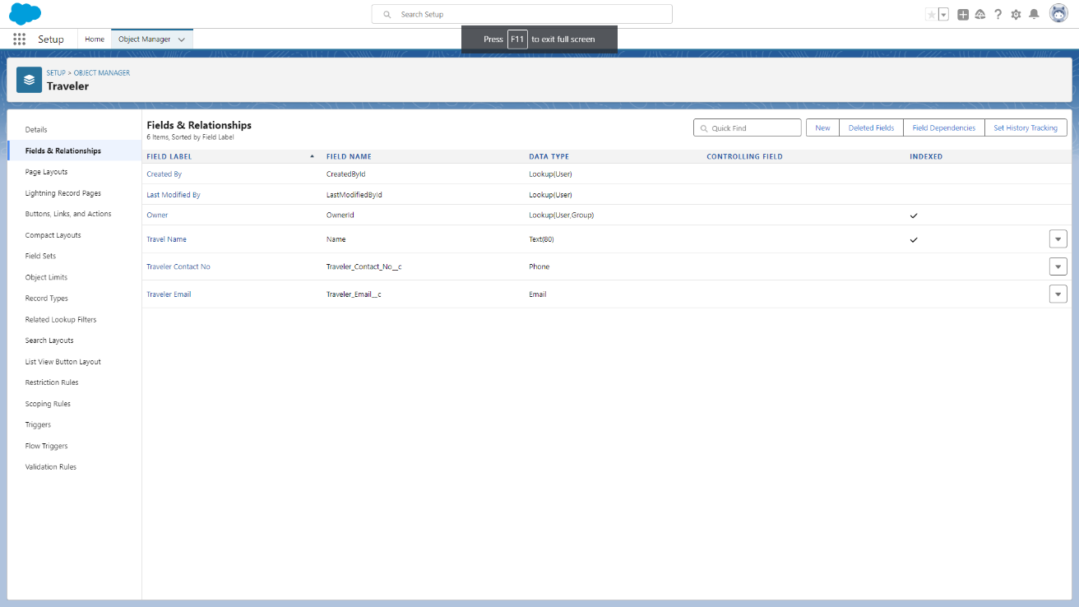

* Vehicle-Maintenance History:

Create a child object related to the Vehicle object to track maintenance history. This would be a custom object with fields like maintenance date, type of maintenance, and cost.

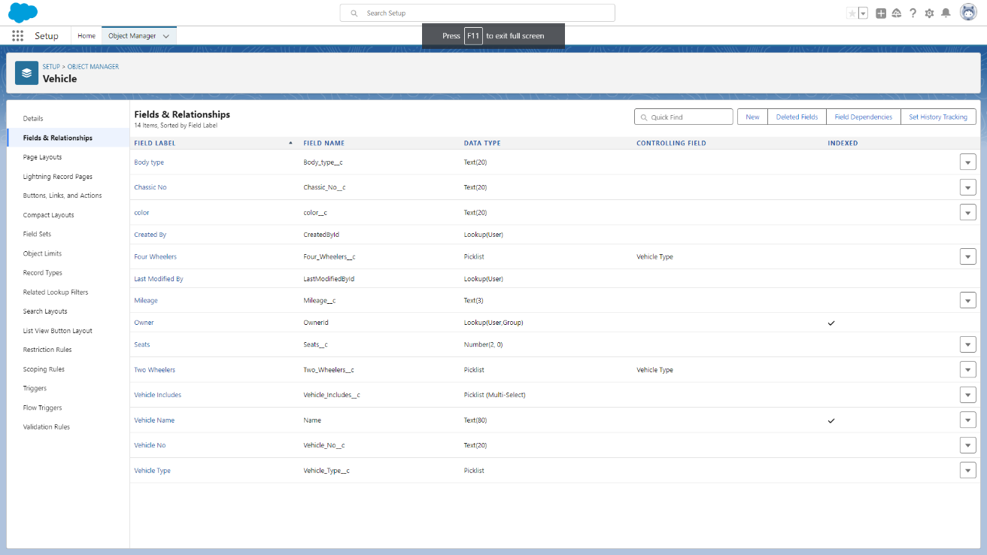

1. **Custom Fields:**

* For each object, add custom fields to capture the necessary information. For example, the Vehicle object may have fields for Vehicle name, Vehicle number, chassis number, color, mileage.

1. **Record Types:**

* Define different record types if your organization handles different types of vehicles (e.g., two-wheeler or four-wheeler). Each record type can have its specific set of fields.

1. **Security and Sharing Rules:**

* Implement appropriate security settings and sharing rules to ensure that only authorized users can access and edit records based on their roles and responsibilities.

1. **Automation and Workflow Rules:**

* Implement automation, such as workflow rules and processes, to automate tasks like assigning drivers, sending notifications, or updating record status.

1. **Validation Rules and Data Quality:**

* Create validation rules to ensure data accuracy and quality. For example, you may want to validate that chassis numbers are in the correct format.

1. **Reports and Dashboards:**

* Design reports and dashboards to provide real-time insights into vehicle availability, maintenance schedules, and driver assignments.

1. **Integrations and Data Imports:**

* Plan for integrations with other systems, if needed, to synchronize data with Salesforce.

1. **Testing and Validation:**

* Test the data model thoroughly to ensure that it meets the project requirements and performs as expected.

1. **Documentation:**

* Document the data model, relationships, field descriptions, and any custom processes or automation for reference and training.

1. **User Training:**

* Train users on how to use Salesforce to manage vehicles, travelers, and drivers effectively.

1. **USERS AND DATA SECURITY**

**Profiles:**

Profiles in Salesforce: Profiles are used to control the permissions and access levels for users. Each user is assigned to a profile that determines what they can and cannot do within the system.

**Roles:**

Roles in Salesforce: Roles are used to define the hierarchy of users within an organization. This hierarchy is important for data visibility and sharing rules. Higher-level users can see records owned by lower-level users.

**Permission Sets:**

Permission Sets in Salesforce: Permission sets are used to extend user permissions without changing their profiles. They allow you to grant additional permissions or access to specific features to certain users or groups.

**Sharing Rules:**

Sharing Rules in Salesforce: Sharing rules are used to open up access to records to users who would not typically have access based on their role and profile. For example, you can create sharing rules to allow managers to view records owned by their team members.

**Record-Level Security:**

Record-Level Security in Salesforce: You can set record-level security using criteria-based sharing rules. This allows you to share specific records with users or groups that meet certain criteria. For example, you might share a vehicle record with a driver if they are assigned to that vehicle.

* Innovative Features: Identify opportunities to innovate within your Vehicle Management System. For example, you could introduce features like predictive maintenance based on vehicle usage patterns or a mobile app for drivers to report issues.
* Problem Solving: Be prepared to address challenges and problems that arise in the management of vehicles, drivers, and travelers. This could involve issues with data integrity, compliance, or operational efficiency.
* User Training: Ensure that your users are well-trained in using the system and are aware of security protocols to prevent unauthorized access or data breaches.
* Continuous Improvement: Implement a process of continuous improvement, seeking feedback from users and iterating on the system to enhance security, performance, and user experience.
* Compliance: Stay up to date with regulatory requirements related to vehicle management, such as data privacy and safety regulations. Ensure that your system complies with these standards.
* Monitoring and Reporting: Use Salesforce reporting and monitoring tools to track user activities and system performance. This can help identify issues and areas for improvement.

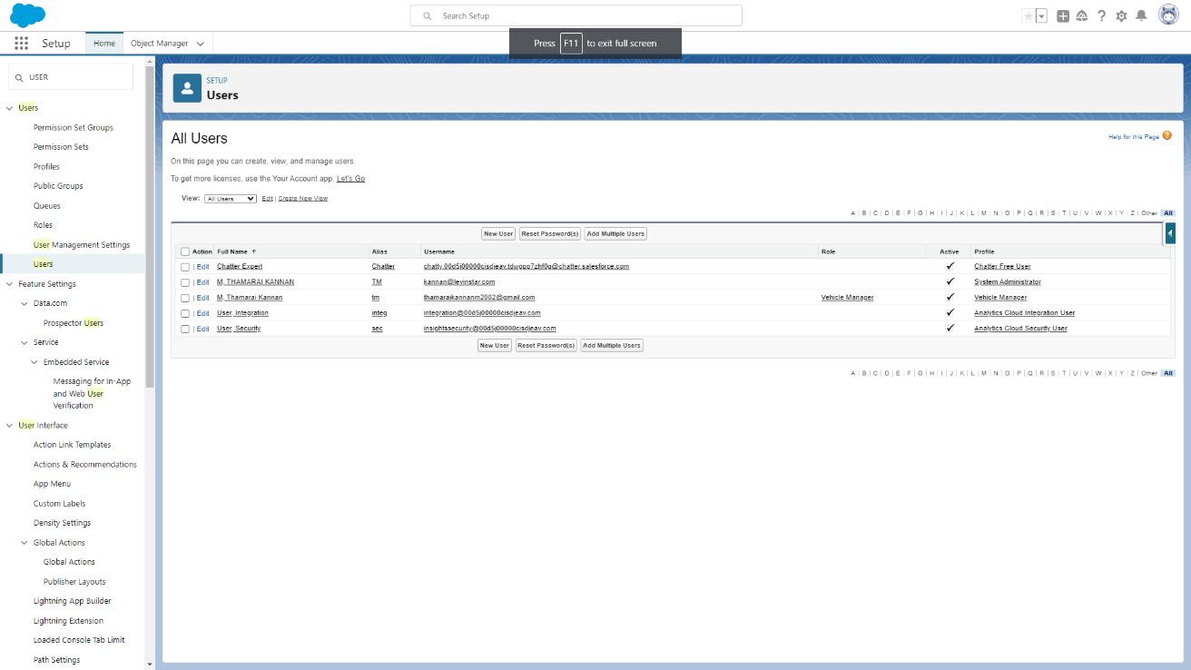

1. **AUTOMATION**

**Triggers:**

* Assignment Rules: Create triggers that automatically assign drivers to vehicles based on predefined criteria. For example, when a new vehicle is added, a trigger can assign the nearest available driver to it.
* Maintenance Reminders: Set up triggers to send maintenance reminders when a vehicle's mileage or time intervals reach specific thresholds. This ensures timely maintenance and extends the life of the vehicles.
* Data Validation: Use triggers to enforce data validation rules. For instance, you can prevent the creation of driver records without valid license information.

**Flows:**

* Booking Management: Implement flows to automate the booking process. Users can initiate a flow to select a vehicle, choose a driver, and confirm the booking. The flow can also handle approvals if needed.
* Inventory Management: Use flows to automate the inventory management process. When a vehicle is booked, the system can automatically update its availability status.
* Driver Onboarding: Create flows to streamline the driver onboarding process. New driver records can be initiated, and necessary information can be collected and validated through the flow.

1. **REPORTS AND DASHBOARDS**

**Reports:**

1. Vehicle Inventory Report:

* Create a report that lists all vehicles in your inventory.

Include details such as make, model, registration, and current status (available or booked).

* Filter and group data to provide a clear overview of your vehicle fleet.

1. Driver Performance Report:

* Build a report that tracks driver performance.
* Include metrics like the number of trips completed, punctuality, and customer ratings.
* Analyze driver data to reward high-performing drivers and identify areas for improvement.

1. Booking History Report:

* Create a report that displays the booking history. Include information on travelers, drivers, vehicles, and trip details.
* Use this report to review past bookings and identify trends. Maintenance Schedule Report:
* Set up a report that provides insights into vehicle maintenance. Include maintenance schedules, last service dates, and upcoming maintenance tasks.
* Ensure that vehicles are well-maintained to prevent breakdowns.

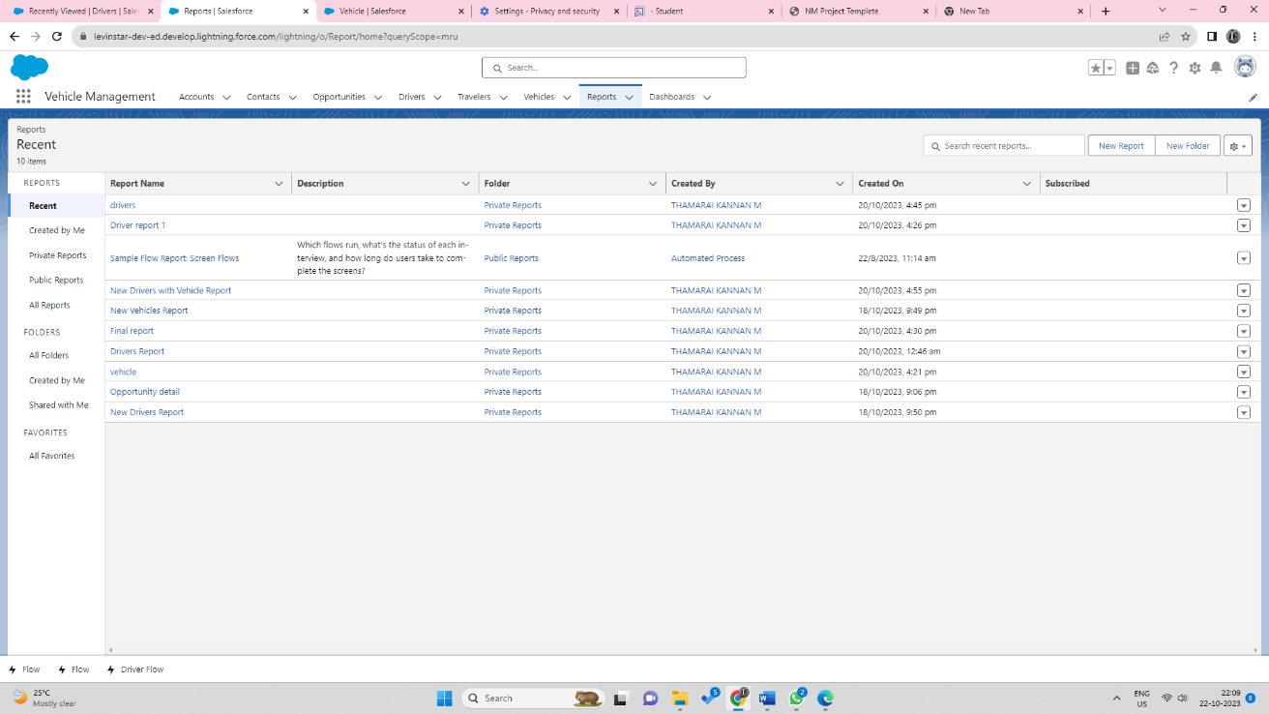

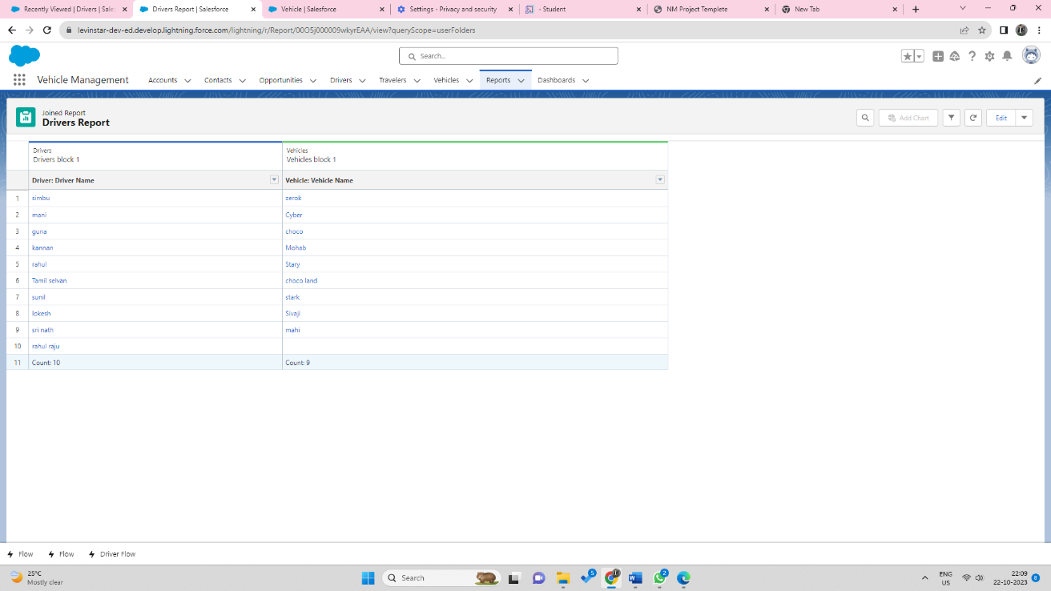

**Dashboards:**

1. Executive Dashboard:

* Create an executive-lsevel dashboard that offers high-level insights for managers and executives. Include components like charts, metrics, and tables summarizing vehicle availability, booking trends, and performance.

1. Vehicle Performance Dashboard:

* Build a dashboard focused on vehicle performance and maintenance. Use gauge components to show maintenance progress and alerts for overdue tasks. Include charts for fuel efficiency and mileage.

1. Booking Management Dashboard:

* Develop a dashboard to manage bookings in real-time. Include a booking calendar component showing upcoming trips.
* Implement components for notifications about new bookings and driver assignments.

1. Driver Performance Dashboard:

* Create a dashboard to monitor driver performance.
* Use charts and tables to display driver ratings, completed trips, and on-time performance. Include a leaderboard component to recognize top drivers.

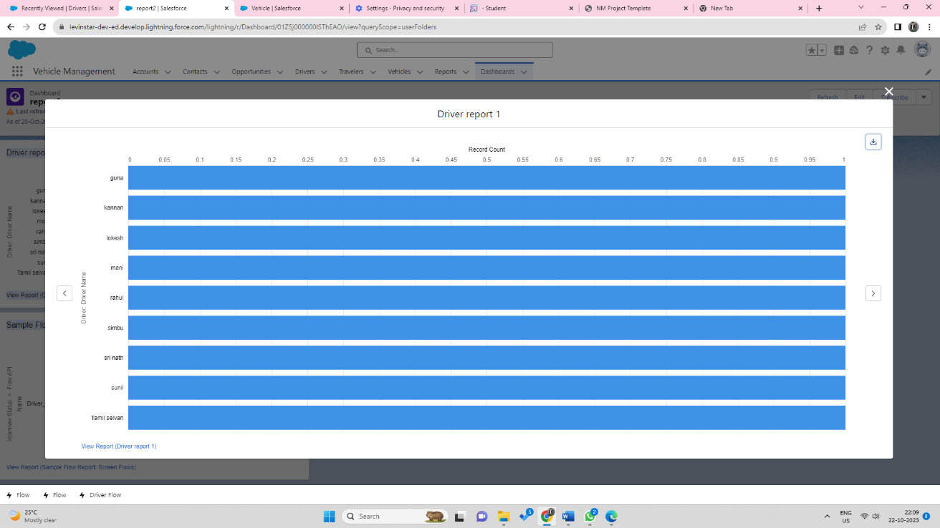

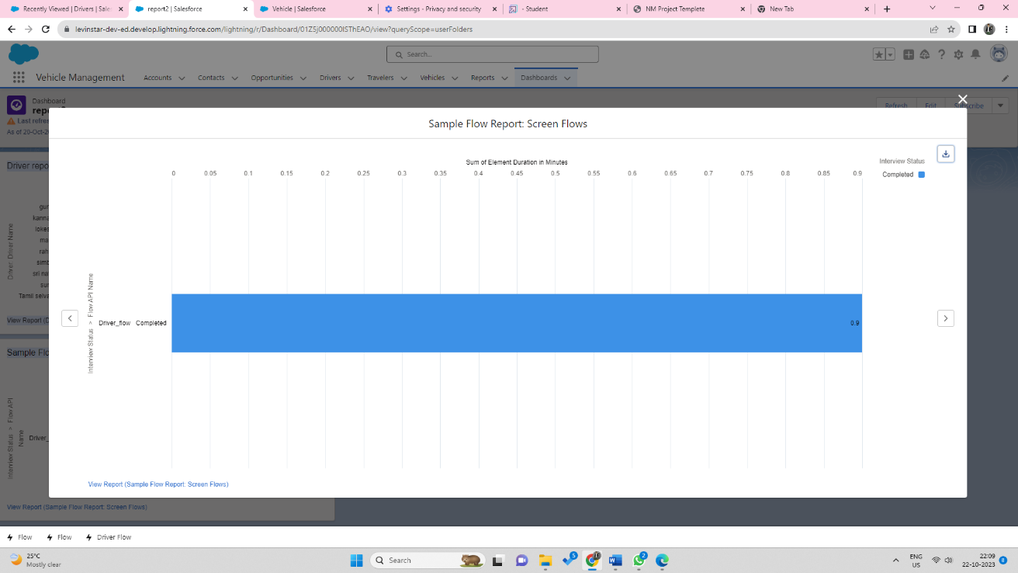

1. **PROJECT REPORT/DEMONSTRATION**

**Demonstration Video link:**

https://drive.google.com/file/d/1ZNQrR5J7-HweUyUlJ4xc0YD_PwWNGWZk/view?usp=share_link